Develop an applet which controls a game played on a normal chessboard (i.e. 8 ×8 squares). There are three figures on the chessboard: two white bishops, colored yellow for visibility, symbolized by the capital letter 'B' and a black rook, here colored blue for visibility, symbolized by the letter 'R'. The bishops are initially located t d4 and g4, and the rook at g8. The squares should be colored light grey (for white), and dark grey (for black), due to visibility concerns. At each push of a button labeled "Step" the figures will "simultaneously" make one move, with a random number of squares, , according to the rules of the chess game (i.e. the bishops can move only diagonally on squares having the same color as the one they were initially placed on; the rook can move on the line or column it currently is located). When two or more figures get on the same square, the one who got there first wins the position eliminating the late figure from the board. The game ends when a single figure rules the board. Then the "Step" button must be rendered inactive.
A sample chessboard showing the chess algebraic notation | The start position
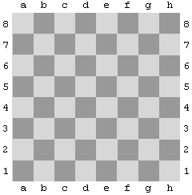
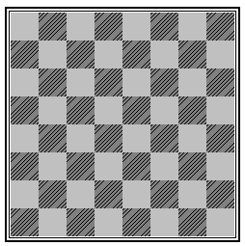
B
B
R

Develop an applet which controls a game played on a normal chessboard (i.e. 8 ×8 squares). There are three figures on the chessboard: two white knights, colored yellow for visibility, symbolized by the capital letter 'K' and a black rook, here colored blue for visibility, symbolized by the letter 'R'. The knights are initially located t d4 and g4, and the rook at g8. The squares should be colored light grey (for white), and dark grey (for black), due to visibility concerns. At each push of a button labeled "Step" the figures will "simultaneously" make one move, with a random number of squares, ,according to the rules of the chess game (i.e. the knights can make L-shaped moves; the rook can move on the line or column it currently is located). When two or more figures get on the same square, the one who got there first wins the position eliminating the late figure from the board. The game ends when a single figure rules the board. Then the "Step" button must be rendered inactive.
A sample chessboard showing the chess algebraic notation | The start position
K
K
R

